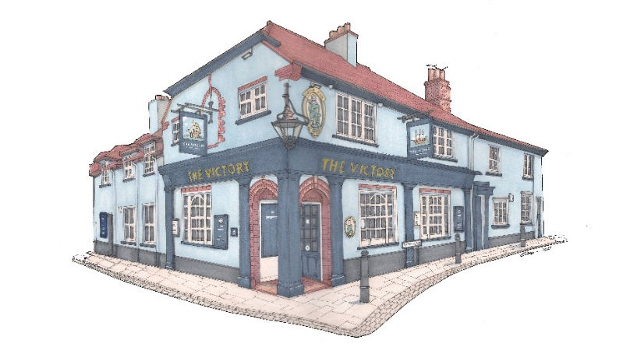
www.victorywalton.co.uk
Starters:
Chicken & apricot terrine, chutney, toast £10
Smoked mackerel pate, toast, cornichons £10
French onion soup, cheese crouton (GF) £10
Sautéed king prawns, garlic & chilli oil (GF) £10
Deep fried whitebait £10
Sauté wild mushroom & spinach, toast * £10
Smoked salmon, sesame, soy dressing. (GF) £10
New Zealand green lipped mussels, garlic butter, parmesan * £10/£16 To share – Hummus, flat bread, tzatziki, olives. (V) £14

Sunday Roast *
Roast 28 day aged Sirloin/Ribeye £29
Roast rump of English lamb £20
Rare breed roast topside of beef £20
Half garlic & herb roast chicken £20
Children’s Roast (beef, chicken or lamb) £10

Mains:
BBQ ribs, fries & red cabbage coleslaw (GF) £20
Beer battered line caught north Atlantic cod fillet, house cut chips, pea puree, tartare. * £20
Brown shrimp & chilli fishcakes, coleslaw & fries. (GF) £19
Arancini, dolcelatte, chargrilled veg, rocket (V) (GF) £19
Cumberland sausage & mash, red onion gravy £19

Desserts: (All Homemade)
Seasonal crumble, vanilla ice cream or custard * £9
Sticky toffee pudding, salted caramel ice-cream, toffee sauce £9
Homemade cheesecake (GF) £9
Trio of ice-cream or Sorbet (GF) £9
Banoffee trifle £9
Triple chocolate brownie, vanilla ice cream (GF) £9
A selection of English & Continental cheeses, water biscuits, and chutney. (Port) £12
Please advise your server of any food allergies or intolerances. * Gluten free option available *

